The Manger
Christmas Menu 2022

Available from Tuesday 29th November throughout December excluding Sundays
pre orders only

Starter
Roasted Butternut Squash and Chilli Soup, crème fraiche and crusty bread and butter (v) (vg option)
Chicken Liver, Bacon and Port Pate, cranberry sauce and melba toast
Prawn and Mango Cocktail, Marie Rose sauce and brown bread and butter
Roasted Plum Tomato, Thyme and Ricotta Tart, salad garnish (v) (vg option)

Main
Roast Turkey Breast, with Yorkshire pudding, roast potatoes, seasonal vegetables, pigs in blankets, cranberry stuffing and roast gravy
Slow Braised Blade of Beef, in a red wine and thyme sauce, creamed mashed potato and seasonal vegetables
Mushroom and Camembert Wellington, stilton cream sauce, baby new potatoes, seasonal vegetables (v)
Pan Fried Lemon Sole, with sizzling lemon and garlic butter, baby new potatoes and seasonal vegetables
Panko Crumbed Chicken Breast, stuffed with chorizo and mozzarella, wild mushroom velouté, roast potatoes and seasonal vegetables
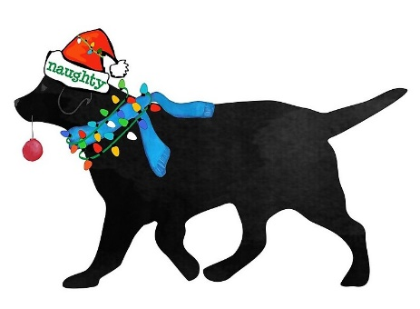
Vegan Sweet Potato, Cranberry and Chestnut Loaf, vegan jus, new or roast potatoes and seasonal vegetables

Dessert
Manger Christmas Pudding, brandy sauce
Bramley Apple and Mincemeat Crumble (vg option)
White Chocolate and Berry Pavlova, raspberry coulis
Honeycomb Chocolate Brownie
Biscoff Cheesecake
all served with either pouring cream, custard or ice-cream

All our menu items are made and prepared in our own kitchen by Chefs Richard, Amie and Darren
1 course £18.95 / 2 courses £23.95 / 3 courses £28.95
with respect a £5pp non-returnable deposit will be required at the time of booking

